[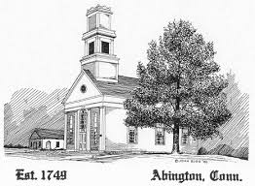](http://www.google.com/url?sa=i&rct=j&q=&esrc=s&source=images&cd=&cad=rja&uact=8&ved=0CAcQjRw&url=http://www.abingtonchurch.org/&ei=gwbIVO3RG4u1ggSf84LoCw&psig=AFQjCNGHmLSIphfx-whdGQFb21G977yMLw&ust=1422481400300120)Abington Congregational Church Newsletter

Summer 2023

A Time of Growth

**PASTOR’S COLUMN**

With pleasure many of us met after church on a recent Sunday with Alvan Hill.  Forty-five years ago, in 1978 he did the renovations to the foundation of the south wall of the church which was sinking.  At the time he took an album of photographs of the work he did, as well as collected some of the old wood he replaced.  These he gave to the church.  It is a fascinating collection, and we were grateful that our own professional photographer Don Pike was there to document the event.

Part of the wood he removed were old pew doors which had been repurposed in the foundation.  He told the story that up until 1840 the Abington church, like all congregational churches of the day, collected Connecticut state taxes on the pews, which were levied on the families seated there.  There was a legal case decided by the state supreme court, which voided this practice as a violation of the separation of church and state; hence the doors were removed.

I am glad that the church is a place which is usually above politics, as politics should be a matter in which people of good will can agree to disagree.  And in spite of some gloomy clouds looming on our horizon, I hope that today's politics can stay that way.

***Bruce*** – [bruce.hedman@gmail.com](mailto:bruce.hedman@gmail.com)

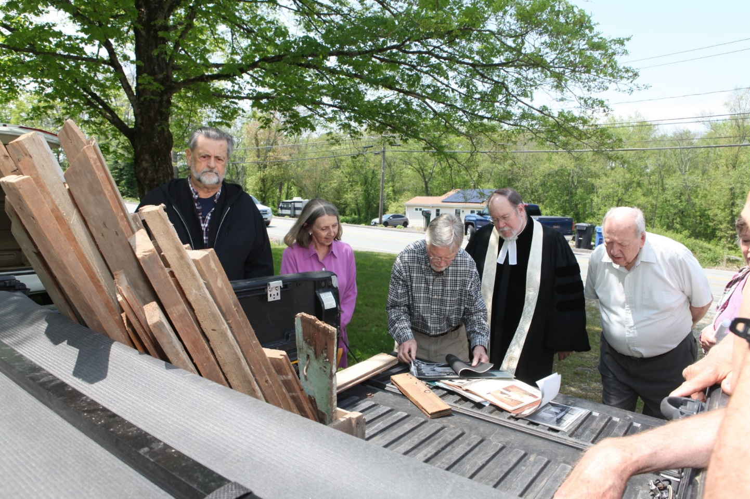

**Dates to Remember**

**June 11th** **–** Get ready to eat and enjoy at The Women’s Guild potluck ‘picnic’ after Sunday Service of Worship. Rain or shine we’ll gather together to not only *ask the Lord’s blessings* but to taste and savor homemade goodies that are truly heaven sent. That is, if heaven delivered delicious food in Tupperware containers. See you on the 11th!

**A Very Special Thanks**

You’ve perhaps noticed the new and welcoming southside threshold to the Meetinghouse. This major improvement was the gift and work of **Dave LaFrance**. And what an upgrade he created! Strong, sturdy and showing all the signs of craftsmanship associated with true artisans. It’s got Dave written all over it. He, once again, has our thanks.

**One Great Hour of Sharing –** Yet again our small but mighty congregation showed its generosity with a combined donation of $420.00 to our denomination’s annual appeal. Monies gathered meet real world needs beyond Abington’s boarders. With a strong contribution from The Deacon’s Fund, we were able to more than ‘pull our weight’ toward helping those we may never meet, whose wants we may never experience but whose humanity we share.

**Palm Sunday, Maundy Thursday and Easter** – It’s a pleasure to report that our Services were so very well attended during Holy Week. There was sun and a hint of warmth at the Sunrise Service. The Meeting House burst with flowers. The music was sublime. Pastor Heman’s sermons educated, enlightened and moved us. A memorable seven days.

**Tracy House** – Our Meetinghouse’s little sister has been in use. A few community events have been held along with providing space and amenities to meet our congregation’s needs. Perhaps some of you drove by on a recent night to see lighted Tiki-Torch’s leading up to the side doorway. Hope you weren’t startled. No, there wasn’t a luau going on. It was a Polynesian themed 8th grade graduation party. Our building sees quite a lot of community use. And with each use an opportunity arises to tell the story of Abington Church and all it has to offer. Folks seem interested. Eager to learn more. We have so much to offer.

**Quick Notes –** Speaking with congregants reveals there’s been an upswing regarding …chickens! Seems like more than a few members have started flocks either for the first time or after a long hiatus. A brief survey indicates that the most popular breeds are; *the one’s my neighbor gave* me which is right behind *some white ones and some that aren’t* white. But the most popular breed by far is *I have no idea.* Eggs are expensive, so we wish all well. Especially the chickens. - And a reminder; keyboard commando, Brenda Pike, is still interested in your suggestions for offertory hymns or tunes. Let Brenda know what you’d like to hear. She’ll make it sound better than you could have imagined. - The Trustees are interested in your thoughts regarding Meetinghouse repairs, maintenance or upgrades. Let them know!

**What is it? -** There’s this tree…or bush…or collection of things…growing at the southwest corner of Tracy House. Whatever it is, it’s confused arborists, students of botany and even philosophers. It *appears* to be part spruce with a dash of maple and even some poplar thrown in. Oh, and there might even be some bayberry growing there too. There seems to be some confusion over that point. There’s a photo of the offending object on the backside of this mailer and whatever it is, it’s big and ugly and in need of…something. Trimming? Definitely. Pruning? Without question. Removal? Well, that’s where you come in. Please let me know either via email ([greenwriter@msn.com](mailto:greenwriter@msn.com)) or speak to me on any given Sunday. Let me know what you’d like to see done to improve a situation that is literally growing out of control. I’ll be happy to attack this monster with some of new ‘old man power trimmers’ of which I’ve recently acquired more than my fair share. But be warned, I’m prone to what Mrs. Newsletter editor terms ‘Q-tipping’ anything I approach with hedge clippers. So, if you’re willing to chance that an anemic looking bonsai tree might appear on our Church property, I’ll start hacking….I mean *shaping* soon.

**Jim Platt**

We recently got to sing ‘Happy Birthday to Jim. The entire congregation joined in to wish him the very best of days because he has given the very best of himself to Abington Congregational Church. To list all that he’s done, all the help he’s given, all the leadership Jim has provided would take more space than we have as well as the abilities of a historian and a writer of greater ability. Can we summarize? Perhaps not, but I think one member of our Church family said it best when he noted, *Jim is distinguished for wisdom and sound judgment. He is a true treasure to the Abington Church and the Pomfret Community.* That he is. And a terrific guy. Happy Birthday, Jim!

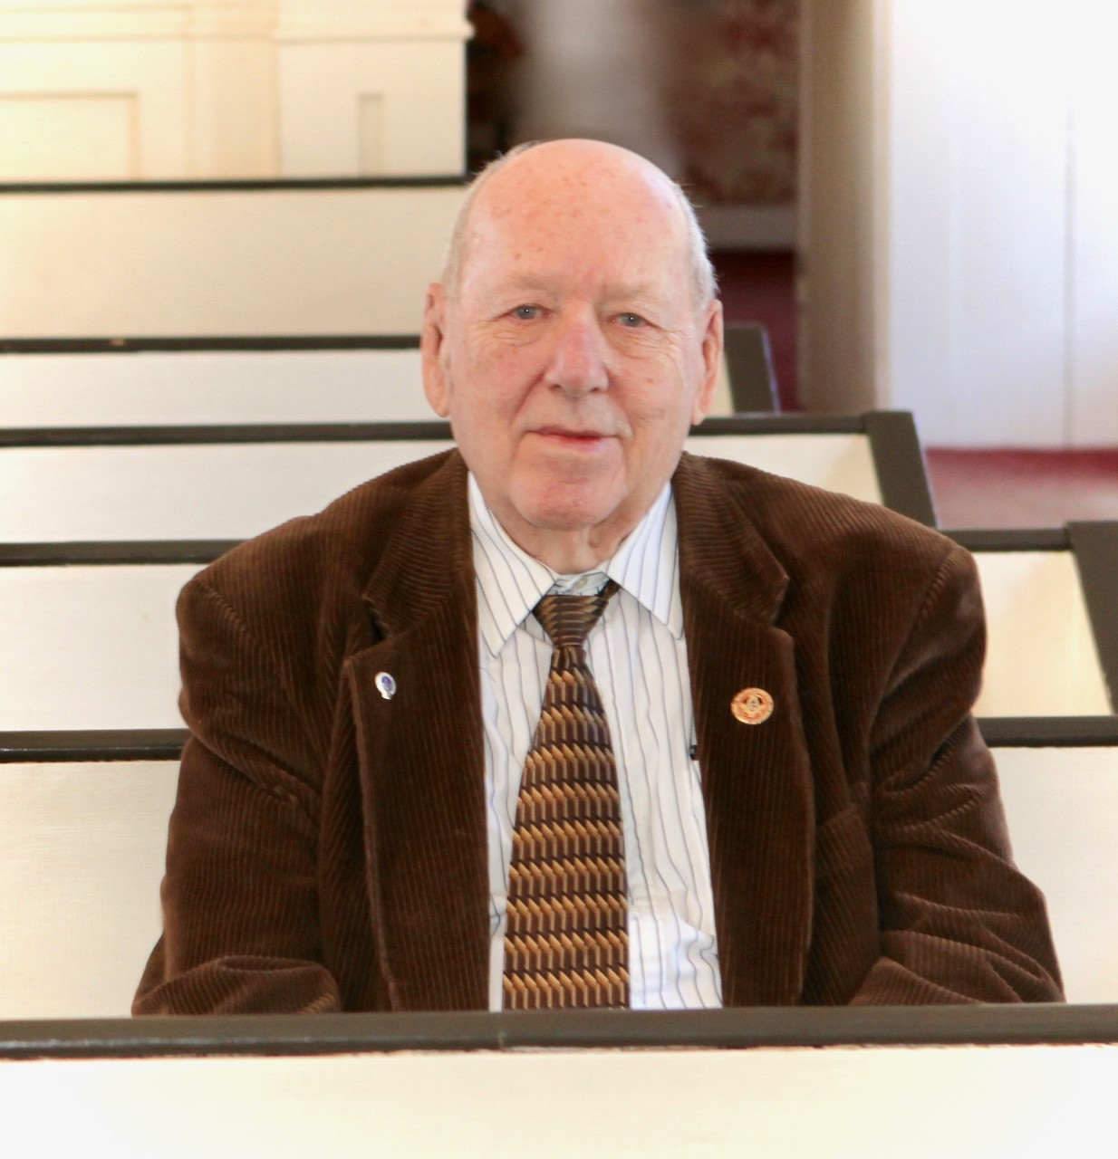

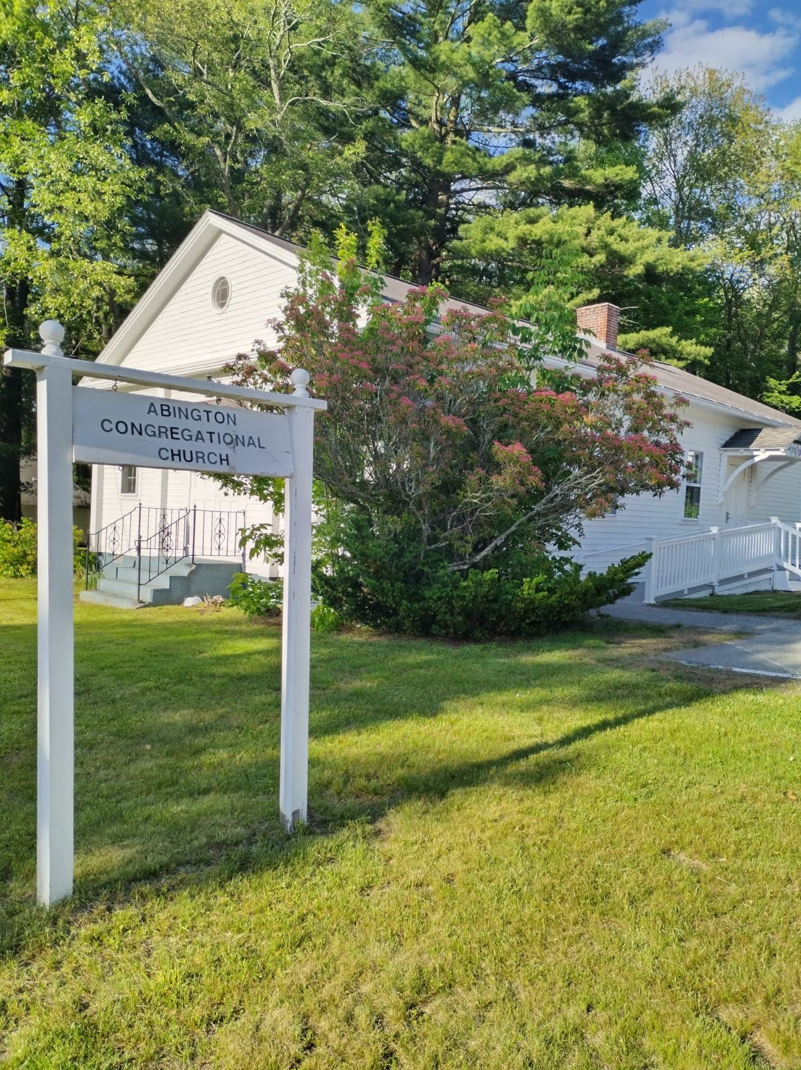

|  |  |  |
| --- | --- | --- |
| Abington Congregational Church  PO Box 289  Pomfret Center Ct 06259``` |  |  |
|  |  | |
|  |  | |